 | Claims Management System  Technical Design Document  1.0
 | Prepared By | Last Updated By | Reviewed By | Approved By
Name | Chandan Kumar Jha | Chandan Kumar Jha | Satyansh Shukla | Shriyans Nidhish
Role | Team Member | Team Member | Team Member | Scrum Master
Signature
Date | 20/03/2019 | 26/03/2019 | 26/03/2019 | 27/03/2019

Table of Contents

1.0 Introduction 3
1.1 Purpose of this document 3
1.2 Scope 3
1.3 Intended Audience 3
1.4 Definition & Acronyms 3
2.0 Assumptions, Dependencies and Risks 4
2.1 Assumptions: 4
2.2 Dependencies: 4
3.0 Use Case Realization 5
3.1.1 Admin Registration 5
a. Functional Requirement 6
b. UI Validations 6
c. UI Controls 6
d. UI Design 7
4.0 Database Design 7
4.1 Data Model 7
The following is a schematic view of the database design 7
4.2 Tables Structure 8
5.0 Change Log 11

Introduction

Purpose of this document
The purpose of the detail design document is to define the detailed design for all the components of Claims Management system that are specified in the Business Requirement/Use case document. All the low level components, interfaces and integrations are detailed out in this document.

Scope
This sub-section shall state the scope of this detailed design document
• Create and maintain Admin information.
• Create and maintain Member and claims information.

Intended Audience
The intended audience for this document are
- Developers, testers, other associates in the project
- Technical lead, Scrum Master
- Product Owner

Definition & Acronyms
Acronyms | Definitions
CMS | Claims Management System

Assumptions, Dependencies and Risks

Assumptions:
- Once the application is built the CLAIMS MANAGEMENT SYSTEM will manually load the admin and member list into the system.
- There will be no concurrent users for the application. The Member profile and claims will be maintained by the Admin.
- Any changes to the design mentioned in the BRD would be taken as a Change Request

Dependencies:
- Availability of database design characteristics & access shall be defined by the
- Resource availability throughout each of the sprint
The above pic is only an example and not representational of the Patient Health project

Use Case Realization

Admin Registration
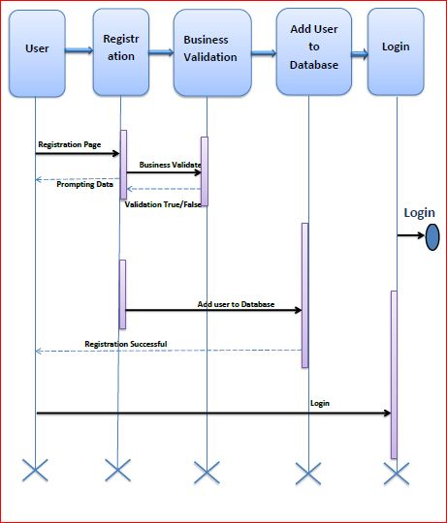

Functional Requirement
. Login Page checks the authentication of the admin and directs the admin to the respective page. Admin will be provided with Claims to be processed, Processed Claims, View New Member and Member Details where he will be allowed to see all the raised claims with member details and the new member registration request.

UI Validations
- Admin Id and Password fields are mandatory.
- Invalid User Id and / or password should not allow the Admin to get into the system

UI Controls
# | UI Component | Type | Name | Details
1 | Admin Id | Label | Admin ID
2 | Admin | Text field | Admin ID | To enter Admin ID
3 | password | Label | Password
4 | password | Text field | Password | To enter password

UI Design


Database Design

Data Model

The following is a schematic view of the database design

Tables Structure
Admin:
Column Name | Field Type | Data Type | Mandatory | Possible Values
Admin Id | Text(10) | Alphabetic | Yes | System Generated
First Name | Text(10) | Alphabetic | Yes
Last Name | Text(10) | Alphabetic | Yes
Age | Number(2) | Numeric | Yes
Gender | Drop Down | NA | N | Male,female
DOB | Text(10) | Alphanumeric | Yes
Contact Number | Text(10) | Numeric | Yes
Alt Contact | Text(10) | Numeric | No
Email ID | Text(10) | Alphanumeric | Yes

Member login:
Field Name | Field Type | Data Type | Mandatory | Possible values
Member ID | Text(10) | Alphabetic | Yes | System Generated
First Name | Text(50) | Alphabetic | Yes
Last Name | Text(50) | Alphabetic | Yes
Age | Numeric(2) | Numeric | Yes
Gender | Drop Down | NA |  | Male, female
DoB | Text(10) | Alphanumeric | Yes
Contact No | Text(10) | Numeric | Yes
Alt Contact No | Text(10) | Numeric | No
Email ID | Text(50) | Alphanumeric | Yes
Password | Text(50) | Alphanumeric | Yes
Plan Code | Text(15) | Alphanumeric | Yes
Coverage Start Date | Test(10) | Alphanumeric | Yes
Covergae End Date | Text(10) | Alphanumeric | Yes
Address Line 1 | Text(100) | Alphanumeric | Yes
Address Line 2 | Text(100) | Alphanumeric | Yes
City | Text(20) | Alphanumeric | Yes
State | Text(15) | Alphanumeric | Yes
Zip Code | Text(10) | Alphanumeric | Yes

Claim:
Field Name | Field Type | Data Type | Mandatory | Possible Values
Clam ID | Auto Generated(5) | Numeric | Yes | System Generated
Member ID | Text(10) | Alphabetic | Yes | System Generated
Claim Service Date | Text(10) | Alphanumeric | Yes
Claim Submission Date | Text(10) | Alphanumeric | Yes
Claim Processing Date | Text(10) | Alphanumeric | Yes
Claim Status | Text(10) Drop Down | Alphabetic | Yes | Submitted,  Approved  Denied
Claim Amount | Numeric(10) | Numeric | Yes | Default 0
Approved Amount | Numeric(10) | Numeric | Yes | Default 0

Change Log
Please note that this table needs to be maintained even if a Configuration Management tool is used.
Version Number | Changes made
V1.0 | <First version>
V1.1 | <If the change details are not explicitly documented in the table below, reference should be provided here>
V1.1 | Page no | Changed by | Effective date | Changes effected
V1.2 | <If the change details are not explicitly documented in the table below, reference should be provided here>
V1.2 | Page no | Changed by | Effective date | Changes effected

